Job Description | Trainee Area Manager
 | Full-time
Company Background

Serve Legal is the UK’s leading retail compliance auditor, enabling market leaders to successfully measure and improve performance, and protect their businesses. We perform independent, undercover on-site audits enabling companies to establish if expected staff performance, operational standards and company procedures are in place.

Serve Legal is a dynamic, growing company delivering over 200,000 audits a year with a UK- wide team of around 2,500 auditors. With expertise in age-restricted sales, retail audit, media compliance and customer experience fields, we are expanding our business into new territories.

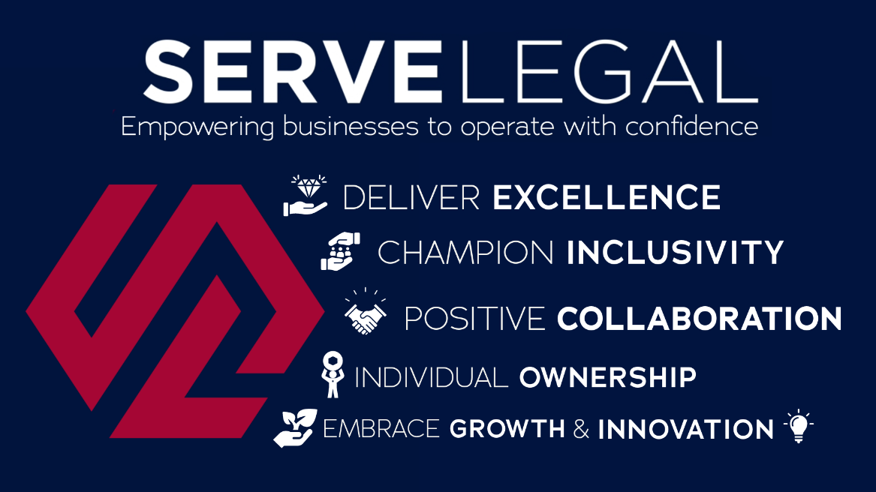

Job Purpose:

To work within a small regional team, taking responsibility for a designated area. Demonstrating the company’s core values to ensure that audits are completed on time and to agreed Key Performance Indicators.
- To build and manage a reliable and tenacious team of auditors to ensure the above.
- To be an effective member of regional and divisional teams, demonstrating positivity and pride
- To contribute to the work of the Operations Group, working collaboratively with dynamism and ambition to build the success of Serve Legal and associated ventures.

Principal Accountabilities:

An effective Area Manager takes ownership of given activities in a designated area and actively seeks to identify improved ways of working and sharing good practice. The main responsibilities of this role are:

- Recruiting and managing an evolving team of auditors, ensuring efficient and cost-effective coverage of the designated region. This involves:
- The early identification of recruitment needs and planning for their resolution
- Taking responsibility for all audit costs in the area
- Allocating and approving audits:
- Briefing and training all auditors as appropriate.
- Monitoring the progress of audits
- Checking audit reports for quality and accuracy.
- Managing auditor performance:
- Identifying and addressing both good and poor performance through the clear communication of objectives and appropriate training.
- Monitoring pass rates (for age test auditors), report quality and costs.
  - Building a sense of community through personal contact and social media

- Regional and divisional responsibilities:
  - Quality Assurance: Play an active role in the auditing process, ensuring the region meets its targets for auditor contact.
  - Recruitment: Recruit auditors using a range of proven methods and identify potential new areas for effective recruitment
  - Special projects: working in areas which fall outside SL core activities as required
  - Divisional support: work collaboratively with colleagues as required to ensure that across the company all visit types are completed accurately and on time.
Behavioural and work-based competencies

- Good time management and organisational skills; an incisive self-starter with the ability to prioritise tasks, demonstrate tenacity and meet deadlines
- Ability to cultivate strong working relationships; a positive and dynamic leader who inspires confidence.
- Decisive; cool under pressure. Reliable and tenacious
- Good communications skills; the ability to communicate clearly whether face to face, by phone or in writing
- Collaborative. Able to motivate and collaborate with others to achieve group targets; take a balanced and objective view; take pride in collective success
- Good understanding of Outlook, Word, Excel; has an understanding of Microsoft Office programmes and the ability to expand knowledge in these areas
- Good presentation skills; able to create a presentation and deliver it to both small and large groups. A confident and intelligent presenter.

Other Requirements:

- The main place of work is the Trainee Area Manager’s home.
- Monthly meetings are held in our London Office. Attendance at all meetings and company events is expected.

