Job Description Auditor
Company Background

Serve Legal is the UK & Ireland's leading retail compliance auditor, enabling market leaders to successfully measure and improve performance, and protect their businesses. We perform independent, undercover on-site audits enabling companies to establish if expected staff performance, operational standards, and company procedures are in place.

Serve Legal is a dynamic, growing company delivering over 200,000 audits a year with a UK & Ireland- wide team of around 2,500 auditors. With expertise in age-restricted sales, retail audit, media compliance, and customer experience fields, we are expanding our business into new territories.

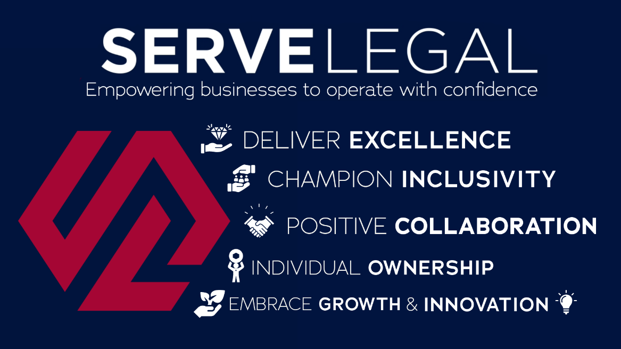

Job Purpose:

We are looking for committed individuals who have great communication skills to perform compliance audits on a range of sites. These audits can be to supermarkets, eateries, betting shops, and more. You’ll be required to make a specific purchase and then submit a report back on the experience. We have opportunities for anyone aged 16 and over, but we particularly require auditors aged 20 and over for our non-age-verification audits, which involves testing customer service and ensuring sites are abiding by their best practice rules.

This is a part-time, flexible role, which is ideal to fit around work schedules and other commitments. Pay is calculated on a per-audit basis, estimated to align with a Real-Living-Wage hourly rate, with audits being allocated as a ‘batch’ that are near to each other. There is no obligation to complete work consistently or regularly, however we do ask that all work that is agreed upon between an Area Manager and auditor is undertaken by its set deadline. Failure to do so with no prior communications may result in us being able to offer you further work.

We offer:

- Flexible work – You can balance work or other commitments effortlessly. We cover the whole of the UK and Ireland, so if you’re moving around the country, you can continue to complete audits no matter what the location.
- Great Pay and Rewards – Earn competitive rates per audit. We also offer bonuses for outstanding performance, including Auditor of the Month/Year awards, and additional income opportunities through our 'Refer a Friend' scheme.
- Travel opportunities – Explore different locations with expenses covered while contributing to keeping improving stores key operational standards.
- Varied work - Each audit presents a new challenge, ensuring you're engaged and motivated every step of the way.
- Career Growth – Our supportive environment embraces personal and professional development. Many of our Project and Area Managers began their journey as auditors like you.
- Free Stuff – Keep what you buy during audits! From shopping to any winnings, you make on betting shop audits.

What we expect from you:
- Clear communication – Communication is key at Serve Legal; you would be expected to communicate with your relevant Project Managers and stick to deadlines when they have been set and agreed.
- Willingness to undertake all aspects of work we offer – We have many different clients so we’re looking for well-rounded individuals who are comfortable in all different settings and scenarios who are willing to give every audit a go.
- A keen eye for detail – With every client means a new process to follow; You’ll be expected to complete audits to the highest standard remembering to note down all key details alongside writing up a report which contains the correct grammar and spelling.
- Access to a car – This is desirable but not essential.

To find out more about this opportunity, check out our welcome video and our Glassdoor reviews:

https://www.youtube.com/watch?v=A6IDM06AN8k

https://www.glassdoor.co.uk/Overview/Working-at-Serve-Legal-EI_IE1473313.11,22.htm

Apply on our website: https://www.servelegal.co.uk/become-a-serve-legal-auditor/

