Job Description | Weekend Operations Assistant
 | Part-time
Company Background

Serve Legal is the UK’s leading retail compliance auditor, enabling market leaders to successfully measure and improve performance, and protect their businesses. We perform independent, mystery on-site and online audits enabling companies to establish if expected staff performance, operational standards and company procedures are in place.

Serve Legal is a dynamic, ambitious, growing company delivering over 15,000 audits per month with a UK- wide team of around 4,000 auditors. With expertise in age-restricted sales, retail audit, media compliance, allergen, home delivery and customer experience fields, we are expanding our business into new territories.

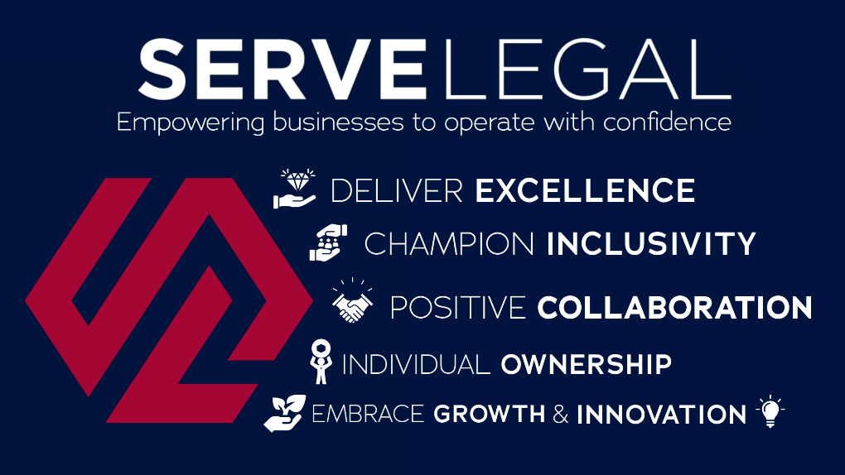

Job Purpose:

To work with Area Managers and the wider Operations team, assigning audits, approving submitted reports to the highest standards and in line with company objectives, and helping with other operational tasks where required over the weekend. Demonstrating the company’s core values to ensure that audits are completed on time.

Principal Accountabilities:

To support the operations team over weekends, working on a designated area, ensuring you are completing set tasks each weekend given to you by the relevant Area Manager. This will include supporting the below responsibilities alongside the Area Manager.

- Supporting to recruit and manage an evolving team of auditors, ensuring efficient and cost-effective coverage of the designated region. This involves:
- Communicating weekly with the area manager, and ensuring all given tasks are completed to the required standard and to deadline with detailed level of feedback for the Area Manager to track.
- Allocating and approving audits:
- Briefing and training all auditors as appropriate.
- Monitoring the progress of audits
- Checking audit reports for quality and accuracy.
- Managing auditor performance:
- Identifying and addressing both good and poor performance through the clear communication of objectives and appropriate training.
- Monitoring pass rates (for age test auditors), report quality and costs.
  - Building a sense of community through personal contact.
You will have the opportunity to increase your hours when volume is high and are expected to respond positively to the needs of the company. This may include opportunities during the week with additional responsibility and/or holiday cover.

Behavioural and work-based competencies

- Good time management and organisational skills; an incisive self-starter with the ability to prioritise tasks, demonstrate tenacity and meet deadlines
- Ability to cultivate strong working relationships; a positive and dynamic leader who inspires confidence.
- Decisive; cool under pressure. Reliable and tenacious
- Good communications skills; the ability to communicate clearly whether face to face, by phone or in writing
- Collaborative. Able to motivate and collaborate with others to achieve group targets; take a balanced and objective view; take pride in collective success
- Good understanding of Outlook, Word, Excel; has an understanding of Microsoft Office programmes and the ability to expand knowledge in these areas
Other Comments:

- The main place of work is the weekend operations assistants home.
- The working hours are 12 hours across each weekend, split evenly between Saturday and Sunday.
- You will be required to work bank holidays.
- You may be expected to attend occasional team meetings in London as required.
- Salary: We follow living wage guidelines.

